
January 28, 2015

OBJECT: What [EDAFCO] can do for sIR,

Dear Sir

At [EDAFCO], we have been producing [JUICE, MILK, YOGHURT, and TOMATO SAUCE] since [1999].

Our expertise in above mentioned product and in [FOOD AND BEVERAGE] provided us with the knowledge to develop our overseas business, and expanded more, We already have many of the country we deal with them.

And we are inviting you to be one of our partners, and it will be our pleasure and proud to deal with you.

In Follow table you will find our specific product attributes.
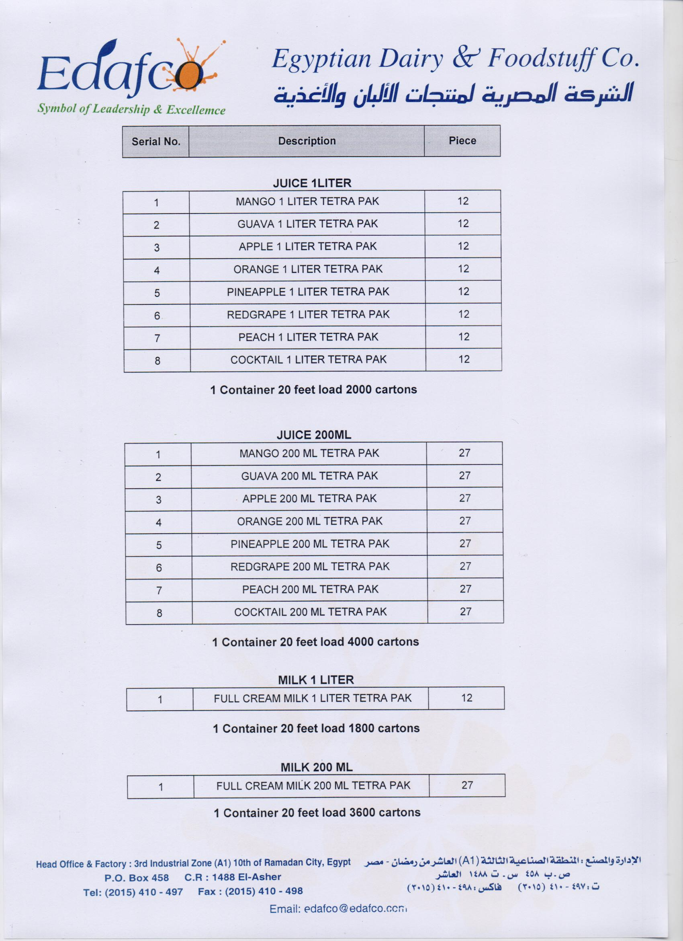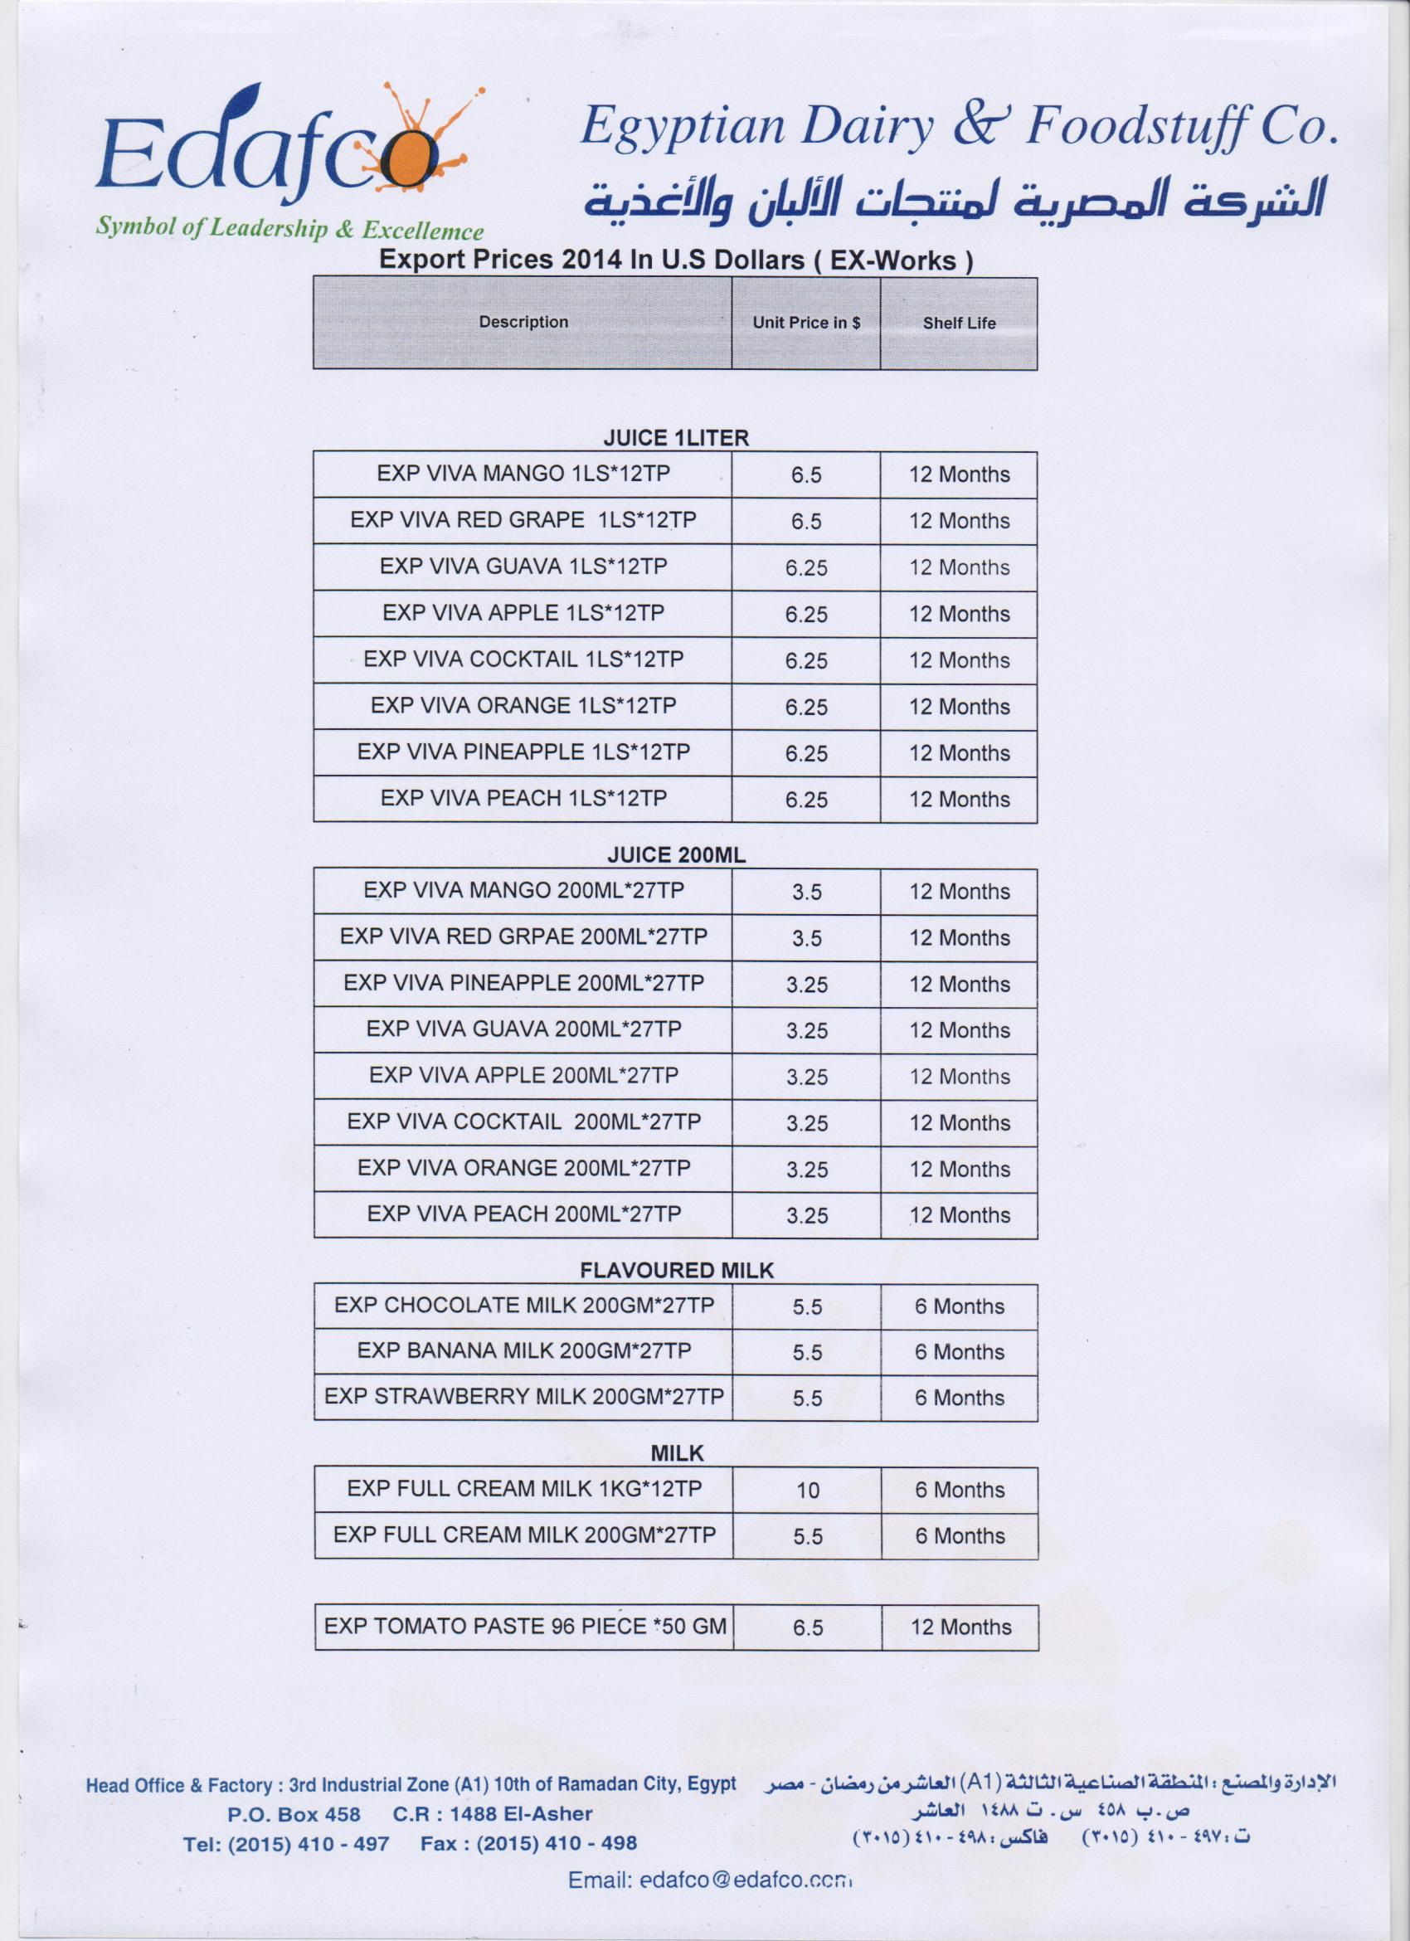
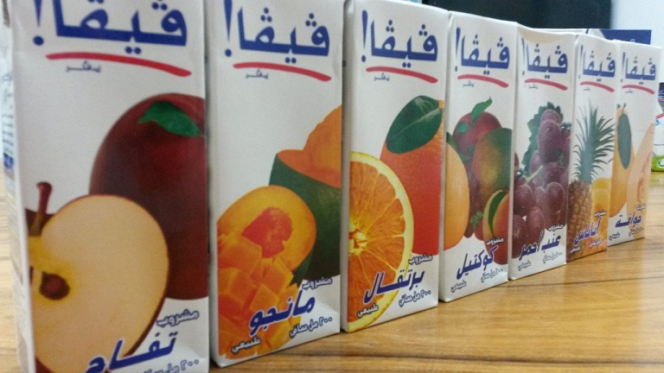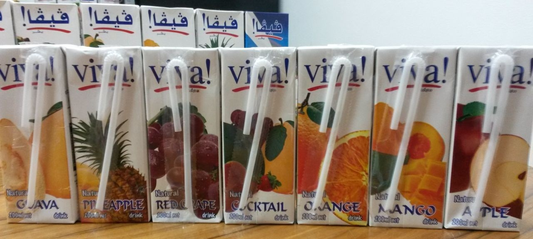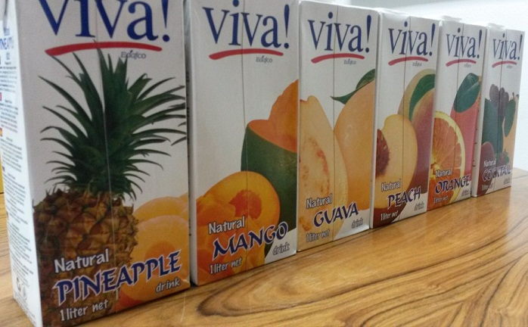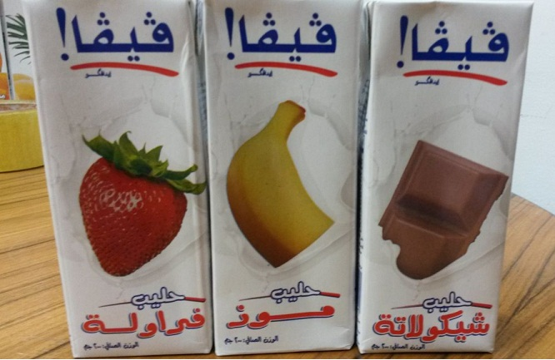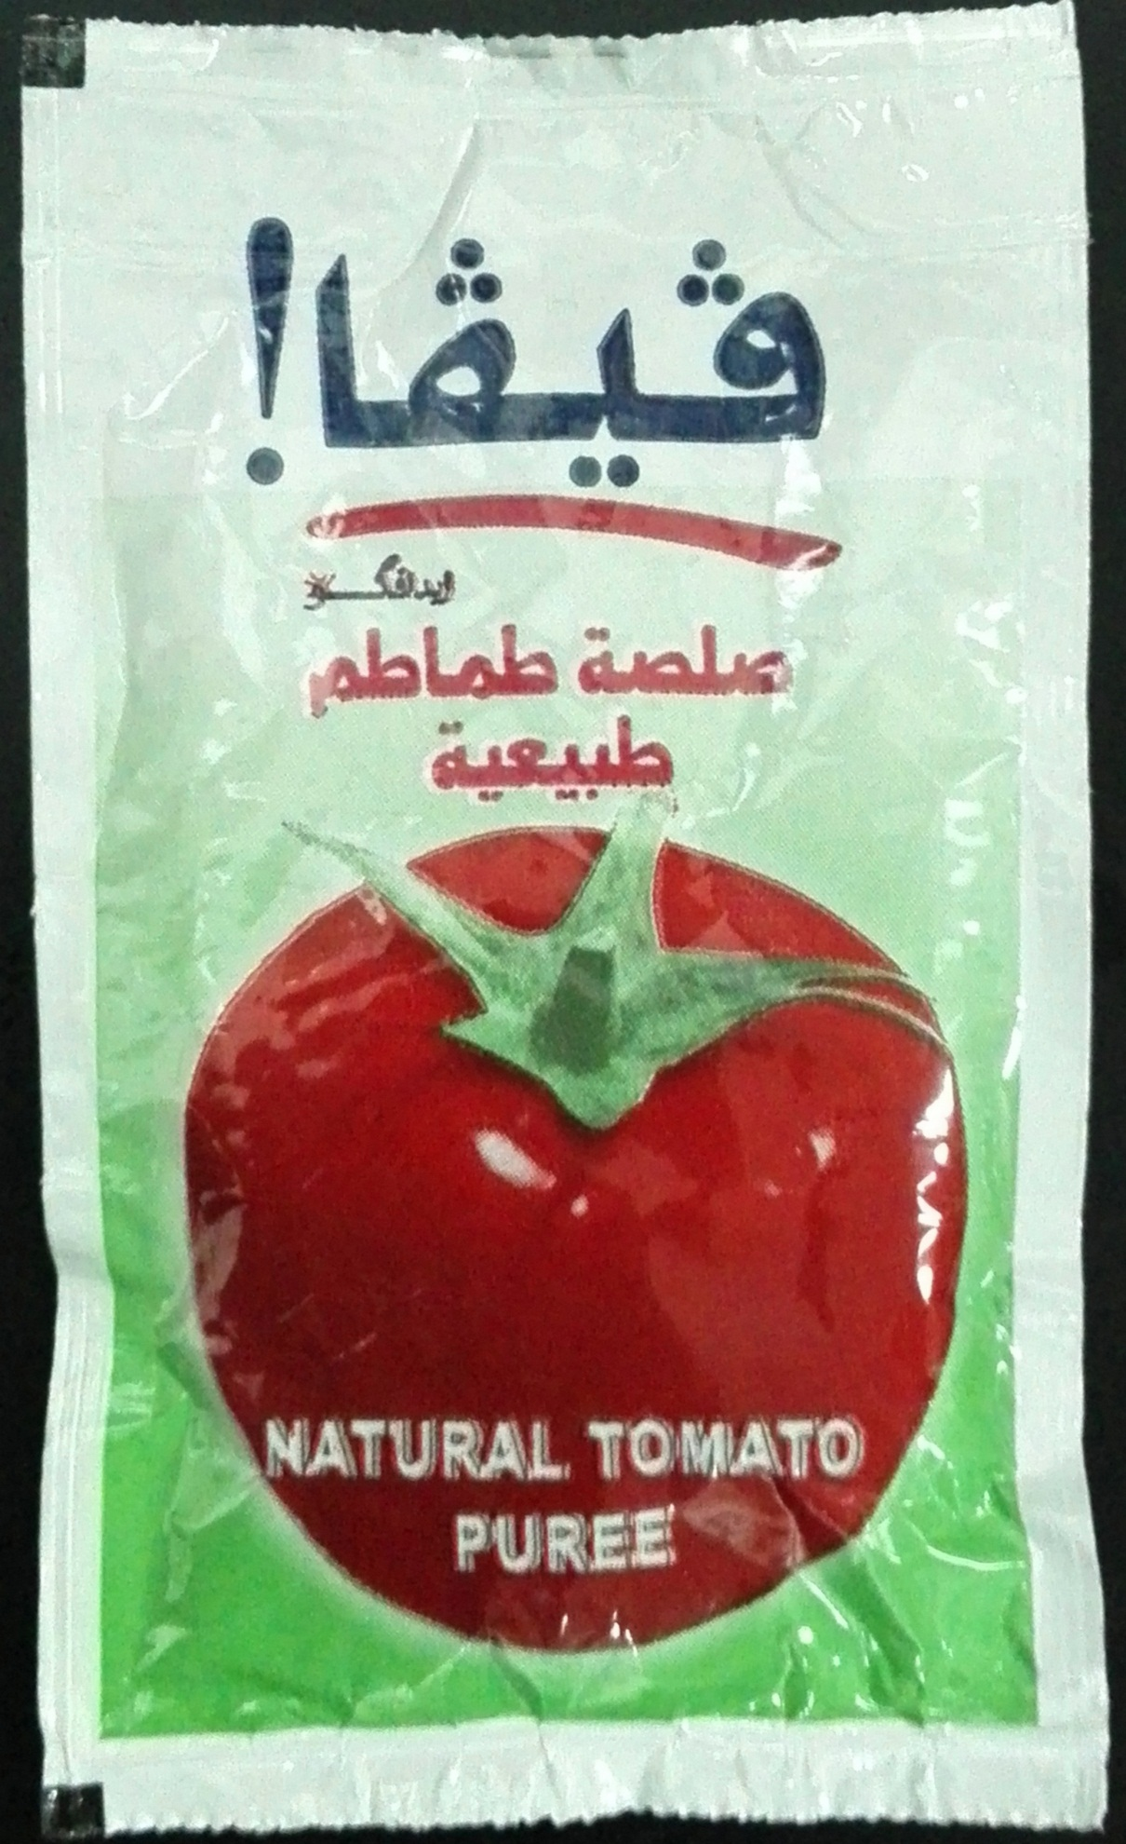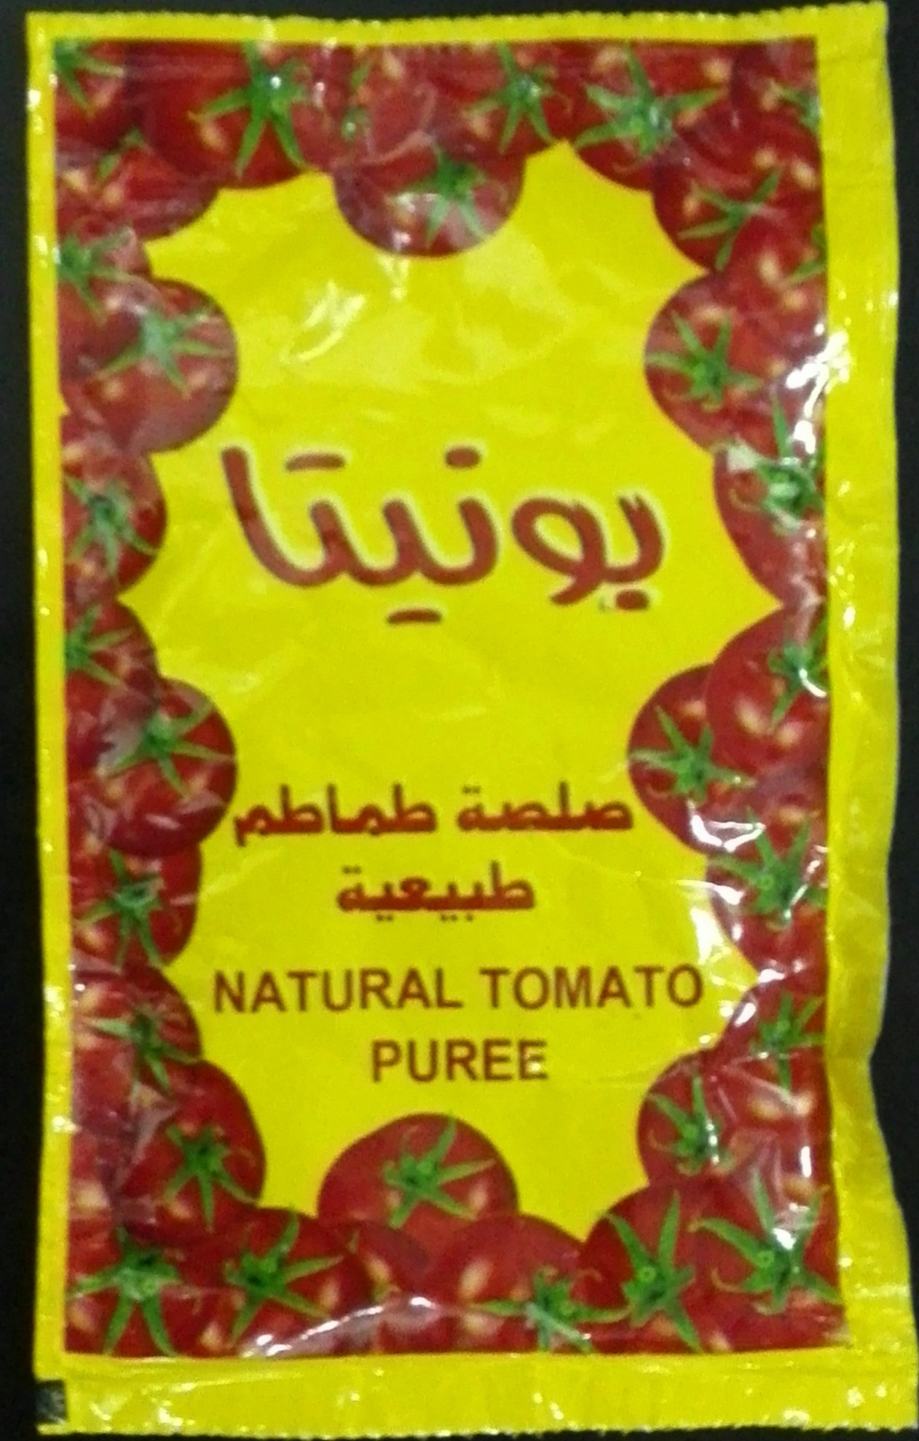

Thanks & best regards

Mohamed Eltahrawy
Export Department

