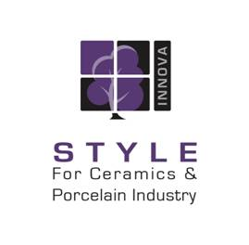
Ceramica Innova Introduction

Style for Ceramic & Porcelain Industry is one of the leading manufacturers of ceramic tiles and sanitary sets in the Middle East and Africa.
Experience, genuine innovation, true knowledge, continuous work and development towards the future, are the basis for rapid advancement and modernization of our establishment. Style for Ceramic & porcelain established in 1989 since then, it has been the pioneer in the field of ceramic tiles, sanitary ware and bathroom accessories immediately became a powerful leader in its field not only in Egypt but also in the Middle East and Africa with production capacity of 100,000 SQM per day & around 40,000,000 SQM per year and in progress for better capacity achievement.
Ceramica innova is our brand Name. Ceramica Innova products include but not limited to: Ceramic wall tiles, Ceramic floor tiles, decor tiles, handmade decorative tiles, heavy duty tiles, sanitary ware, and decorated sanitary ware & Bathroom accessories. Today Ceramica innova has around 40 % of the material used in the manufacturing process as imported from the best quality materials in Italy, and around 60 % of it is from our world famous rich Egyptian soil. The company continues to expand and offer its customers exceptional quality by drawing on more than 25 years of experience.
The flexible commercial policy of the company and its own huge & distinguished productive capabilities shared in increasing the influence of its trade mark in the region. Accuracy, quality, , competitive prices, fine taste and genuine designs are the important characteristics guaranteed only by a giant industrial group such as Ceramica innova which completely fulfils the needs and the taste of any market or client with high international standards of elegance and beauty that suits all levels.

To know more about Ceramica innova & see our designs, please visit our website: www.ceramicainnova.com
& for more information you can contact us on:
Tele: (+2) 02 21800 838- (+2) 02 21800 334
Fax: (+2) 02 21800 826
E- Mail: export@ceramicainnova.com

