
Established 1988
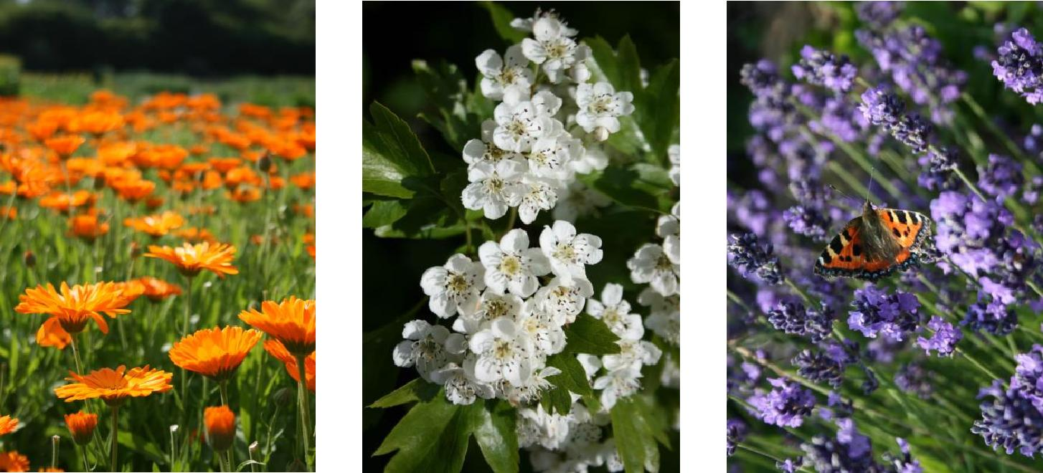

Telephone : 0201001699937
FAX:- 002024045461
EMAIL:Omar.ELDEEB@dtcegypt.com
Website: www.dtcegypt.com
Contents
 | Page
Ordering Information | 1-2
Certification and Accreditation | 3-4
Key | 5-6
Dried Herbs and Spices | 7-12
Herb Field Production - Dry | 13
Terms and Conditions of Sale | 14-17


Ordering information | 1
Minimum order: 20ft container.
When placing an order please include the details below:
Please consider the below details when placing an order ,
- Units required - i.e. number of Ton
- Full product name
- Part of product required - i.e. root, flower, herb, etc
- Packaging.
- Delivery requirement : as per agreement
Delivery charges
All Delivery by over sea or plan
NOTE
Any Simple required HAVE Delivery charges
Payment:
Our preferred payment method is directly through our bank or L/C . For sterling payments our bank details are as follows: A/C NO. 19660150 BANQUE DU CAIRE.ELZOHOUR BRANCH NASR CITY.CAIRO EGYPT swift code BCAIEGCX196
USD bank details please contact us.
How to contact us
Orders can be taken between 24 Hour. Telephone:- +20201001699937
FAX:- +2024045461
Factory address: EL NAZlA in FAYOUM CITY IT’S SOURCE HERBS AND SPICES IN EGYPT
Write to: El Deeb Trading Company, Nasr City, Cairo, 8320Egypt. Email:omar.eldeeb@dtcegypt.com
Website: www.dtcegypt.com
Sourcing of non-stock items
We buy and sell many products that are not promoted in our price list. With our wide range of sources from many different cities from Egypt, we can add new product lines as stock items if there is sufficient or regular demand. Please contact our sales team with any enquiries.

Certifications& documents of ElDeeb Trading Company for Export and Import | 3
Our policy
We are fully aware of the important roles of product’s quality. Thus, our company have been trying our best to gain the deepest belief as well as satisfying the full demands of our valued customers by applying and maintaining the Quality Management System as ISO 9001:2000 and ISO 9001:2008. We commit to implement as follow: 1. Supplying to our customers with the best quality, corresponding to the specifications of products showed signed contracts. 2. Maintaining the Quality Management System, complying the full requirements of ISO 9001:2000 and ISO 9001:2008& documents of ElDeeb Trading Company for Export and Import.
- Commercial Registration Certificate- Exporters Registration Certificate

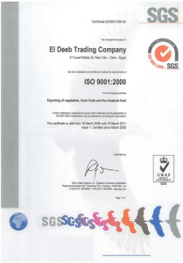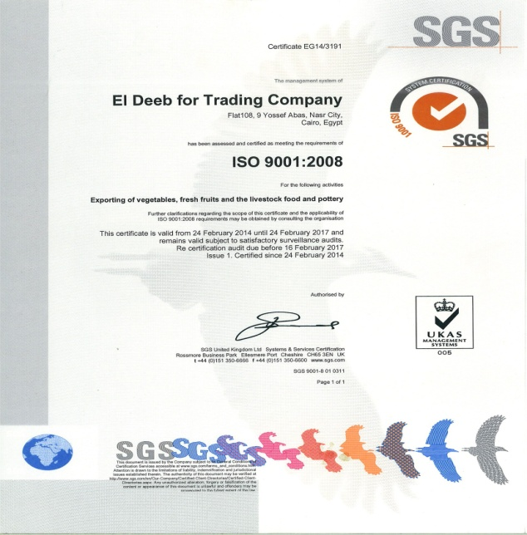

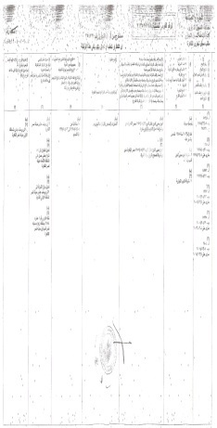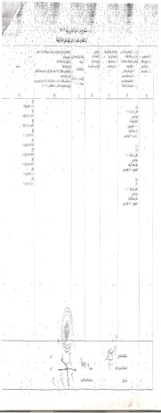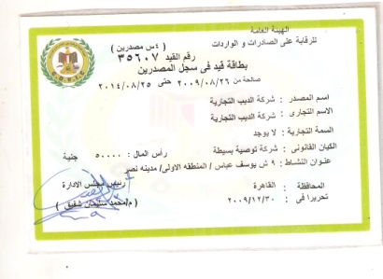

4

Key
PoA=Please contact us for pricing and availability
TBC=Tea bag cut
= Price Decrease
= Price Increase

5
DRIED HERBS AND SPICES
 |  | Product |  |  |  |  | Botanical Name | Part |  | Price For/C.I.F.
 |  | Anis seeds Grade A Quality |  |  |  |  | Pimpinella anisum | seeds |  | 5475$
 |  | Anis seeds Grade B Quality |  |  |  |  | Pimpinella anisum | seeds
 |  | BASIL OVER 1MM/3mm/28mm/50mm) |  |  |  |  | Agrimonia eupatoria | leaf |  | 3775$
 |  | BASIL LARGE CUT: |  |  |  |  | Agrimonia eupatoria | leaf
 |  | BASIL SELECTED: |  |  |  |  | Agrimonia eupatoria | Leaf
 |  | BASIL CRUSHED |  |  |  |  | Agrimonia eupatoria | Leaf
 |  | BASIL POWDER TBC |  |  |  |  | Agrimonia eupatoria | Leaf
 |  | BASIL 2ND QUALITY |  |  |  |  | Agrimonia eupatoria | Leaf
 |  | Black Cumin |  |  |  |  | Nigella sativa | seeds |  | 3775$
 |  | Caraway seeds Grade A Quality |  |  |  |  | Carum carvi | Seed |  | 3775$
 |  | Caraway seeds Grade B Quality |  |  |  |  | Carum carvi | Seed
 |  | Celery Fine cut Grade A |  |  |  |  | Apium graveolens | Seed |  | 4200$
 |  | Celery 30 Mesh |  |  |  |  | Apium graveolens | Seed
 |  | Celery crushed leaves 2-4 mm |  |  |  |  | Apium graveolens | Seed
 |  | Celery powder |  |  |  |  | Apium graveolens | Seed
 |  | Chamomile 1st QUALITY46 |  |  |  |  | Matricaria recutita | flower |  | 8875$
 |  | Chamomile POWDER 18-22 |  |  |  |  | Matricaria recutita | flower
 |  | Chamomile1st TBC 12 |  |  |  |  | Matricaria recutita | flower
 |  | Chamomile2ed TBC 2 |  |  |  |  | Matricaria recutita | Flower
 |  | Chamomile PETALS 6-10 |  |  |  |  | Matricaria recutita | Flower
 |  | Chamomile STEMPS 8-10 |  |  |  |  | Matricaria recutita | Flower
 |  | With crushed over 2mm/16mm/50mm
 |  | Chamomile POLLEN 15-20 |  |  |  |  | Matricaria recutita | Flower
 |  | Chamomile 2ed QUALITY 26 |  |  |  |  | Matricaria recutita | Flower
 |  | Coriander1st QUALITY 18 |  |  |  |  | Coriandrum sativum | seed
 |  | Coriander2ed QUALITY 16 |  |  |  |  | Coriandrum sativum | Seed
 | Cumin 1st QUALITY 27 |  |  |  |  | Cuminum cyminum |  |  | Seed | 5475$
 | Cumin2ed QUALITY 25 |  |  |  |  | Cuminum cyminum |  |  | Seed
 | Dill Tips crushed Leaves 30 |  |  |  |  | Anethum graveolens |  |  | Leaf | 5800$
 | Dill seeds 16 |  |  |  |  | Anethum graveolens |  |  | seeds
 | Dried lemon (black /yallow)  Size as required 18 |  |  |  |  | Citrus Aurantifolia |  |  | units | 4200$
 | Dried Lemon Powder 12 |  |  |  |  | Citrus Aurantifolia |  |  | units
 | Fennel seeds Grade A Quality 10 |  |  |  |  | Foeniculum vulgare var.dulce |  |  | seeds | 2500$
 | Fennel seeds Grade B Quality 8 |  |  |  |  | Foeniculum vulgare var.dulce |  |  | seeds
 | Fennel seeds Cracked QualityA8 |  |  |  |  | Foeniculum vulgare var.dulce |  |  | seeds
 | Fennel seeds Cracked QualityB4 |  |  |  |  | Foeniculum vulgare var.dulce |  |  | seeds
 | Fennel seeds Pure Powder 8 |  |  |  |  | Foeniculum vulgare var.dulce |  |  | seeds
 | Fenugreek seeds Grade A Quality 8 |  |  |  |  | Trigonella foenum-graecum |  |  | seeds |  | 2400$
 | Fenugreek seeds Cracked Quality6 |  |  |  |  | Trigonella foenum-graecum |  |  | seeds
 |  |  |  |  |  | Hibiscus sabdariffa |  |  | Flower |  | 4200$
 | Hibiscus whole flowers:17.5
 | Hibiscus crushed flowers:12 |  |  |  |  | Hibiscus sabdariffa |  |  | Flower
 | Hibiscus sifting (T.B.C):10 |  |  |  |  | Hibiscus sabdariffa |  |  | Flower
 | LEMONGRASS 1/2cm( 7.5) |  |  |  |  |  |  |  | Root |  | 2750$
 |  |  |  |  |  | Cymbopogon citratus
 | LEMONGRASS 1cm (6.5) |  |  |  |  | Cymbopogon citratus |  |  | Root
 | LEMONGRASS 5 CM (5.5) |  |  |  |  | Cymbopogon citratus |  |  | Root
 | LEMONGRASS (TBC)4 |  |  |  |  | Cymbopogon citratus |  |  | Root
 | Laurel leave 16 |  |  |  |  | Laurus nobilis |  |  | Leaf |  | 3900
 | Laurel leave crushed 12 |  |  |  |  | Laurus nobilis |  |  | Leaf
 | Marigold | 19 |  | Calendula officinalis | flower | 4275$
 | Marigold PETALS 32 |  |  | Calendula officinalis | Flower | 6100$
 | MARJORAM SELECTED 22 |  |  | Origanum marjorana | leaf | 4750$
 | MARJORAM GREEN 19.5 |  |  | Origanum marjorana | Leaf
 | MARJORAM GRAY 19 |  |  | Origanum marjorana | Leaf
 | MARJORAM FINE CUT 1mm 19.5 |  |  | Origanum marjorana | Leaf
 | MARJORAM GREEN / GRAY | 20 |  | Origanum marjorana | Leaf
 | MARJORAM FINE CUT 4mm 20/ |  |  | Origanum marjorana | Leaf
 | MARJORAM POWDER16 |  |  | Origanum marjorana | Leaf
 | Molokai Leaves 23 |  |  | Origanum marjorana | leaf | 4875$
 | Mint Hay 6 |  |  | Corchors olitorius | leaf | 2500$
 | Olive leaves 5/guava leaves/5 |  |  | Olea europaea | Leaf | 2200$
 | Parsley Fine cut 16 |  |  | Petroselinum crispum | Leaf | 3975$
 | Parsley crushed leaves 2mm11 |  |  | Petroselinum crispum | Leaf
 | Parsley crushed leaves4 mm 14 |  |  | Petroselinum crispum | Leaf
 | PEPPERMINT CRUSHED 18 |  |  | Mentha x piperita | Leaf
 | PEPPERMINT FINE CUT 22 |  |  | Mentha x piperita | Leaf
 | PEPPERMINT POWDER TBC15 |  |  | Mentha x piperita | Leaf
 | PEPPERMINT LARGE CUT 25 |  |  | Mentha x piperita | Leaf | 5150$
 | SPEARMINT CRUSHED14 |  |  | Mentha spicata | Leaf
 | SPEARMINT POWDER11 |  |  | Mentha spicata | Leaf
 | SPEARMINT LARGE CUT 19 |  |  | Mentha spicata | Leaf | 4325$
 | SPEARMINT LEAVES 18 |  |  | Mentha spicata | Leaf
 | SPEARMINT FINE CUT 18.5 |  |  | Mentha spicata | Leaf
 | Sage officinalis cut |  |  | Salvia officinalis | Root | 3800$
 | Senna |  |  | Cassia angustifolia | Berry | POA
 | Thyme Grade Quality A 16 |  |  | Thymus vulgaris | Fl herb | 3975$
 | Thyme Grade Quality B 14 |  |  | Thymus vulgaris | Fl herb

We have Other Product:
NIGELLA SEEDS (Black Cumin seeds)/sage (POWDER, CRUSHED, TEA BAG CUT)/sun flower seeds for animal feed/White Pumpkin pulp/Pumpkin (wood pulp)/ Egyptian pulp/Lemon Leaves/Rose of Jericho/Safflower plant/
licorice leaves/Licorice seeds‬‏/Bitter Melon or Bitter apple/Saffron/Plant Alortp/ ginger/Malva parviflora/ Purslane/Henna/ Senna/ kidney Beans ( White Beans) /Handal/Caorb(POWDER, CRUSHED, TEA BAG CUT)/Olive leaves/ Guava leaves/Laurel Leaves/bay leaves/SESAME SEEDS /Rosemary/Barley/Alfa alfa powder/ Onion powder(slices)/Carrot Powder/Tomato powder/ Garlic powder/Turmeric/DUOM(ONLY IN EGYPT)

HERB FIELD PRODUCTION - DRY

DTC EGYPT has 27 years of experience in organic herb production. We typically grow around different Herbs, often experimenting with new growing techniques and establishing little used and endangered plants.

We can offer the following products and services:

*Dry herbs, delivered when you Choose
*Dried herbs, making full use of DTC Egypt herb processing facility to offer whole, cut or powdered product to customer specification

*A contract growing service, either producing herbs from our farm or using our network of local producers from Aswan city/Fayoum city/ Different cities from Egypt
 | Product | Botanical Name |  | Part
 | Marigold | Calendula officianalis |  |  | flower
 | Peppermint | Mentha piperita |  | Leaf
 | Spearmint | Mentha spicata |  | Leaf
 | Chamomile | Matricaria recutita |  |  | flower

TERMS AND CONDITIONS OF SALE
EL Deeb Trading company Trading Company Ltd

1 APPLICATION OF CONDITIONS:
All herbs (“the Goods”) sold by EL Deeb Herb Trading Company (“we”, “us”, “the Company”) are sold under these Conditions unless otherwise clearly stated in writing under a separate contract. These Conditions will apply to the exclusion of any terms or conditions put forward by the Customer. No other representation by the Company should be deemed to constitute the acceptance of any terms or conditions other than these Conditions.
2 PRICE LISTS AND SALES LITERATURE:
Prices given in our price lists or other sales literature are for information purposes only, and do not constitute an offer of contract. No contract will come into existence until the customer's order (however given) is accepted. Invoices will be raised for prices current at time of order.
While every effort is made to deliver goods at the prices listed, all prices quoted are subject to alteration without notice to take account of fluctuations in the cost of labour, goods, rates of exchange, import duty and any other cost that The Company may incur in the normal course of business.
3 CARRIAGE:
Except as otherwise stated in any quotation or price list of the Company, or as otherwise agreed in writing, all prices are given by the Company on an ex-works basis and exclude transport.
4 DELIVERY:
Any dates quoted for delivery are approximate only. We will use reasonable endeavors to effect delivery on agreed dates based on information available at time of quoting; we accept no responsibility for any loss resulting from delays to delivery or from any deterioration in quality resulting from such delays.
5 PAYMENT:
For non-account Customers payment is required in cleared funds before dispatch. For account Customers payment is due within 30-42 days from invoice date and goods will not be released if overdue balances have not been paid.
6 OWNERSHIP OF GOODS:
Under our standard terms the responsibility ownership and risk of the goods pass at the point of delivery.
7 DAMAGED GOODS & SHORT ORDERS:
Any claim that goods have been delivered damaged, are not of the correct quantity or do not comply with their description must, unless notified to the carrier at the time of delivery, be notified by the Customer to the Company in writing within 3 days of their delivery.
8 STORAGE:
We will be under no liability for any defect in the goods (including, but not limited to, infestation or mould) arising from incorrect storage by the Customer. Dried herbs stored in optimum conditions will remain active for long periods. They should be kept in airtight, opaque containers in a cool place and out of direct sunlight.
9 QUALITY:
Every effort is made to ensure the goods supplied are of high quality and in good condition. If we are satisfied that the products have been stored in optimum conditions and the Customer finds the quality unacceptable, we will at our discretion refund the cost or exchange the goods up to three months from date of delivery. The Company must be afforded a reasonable opportunity and facilities to investigate any claims made under this condition.
10 SEASONAL SHORTAGES & OUT OF STOCKS:
Please note that some herbs are subject to seasonal shortages. While every effort is made to keep our complete range of products in stock, we do not accept any responsibility for loss resulting from any out of stock items.
11 PRODUCT SUITABILITY:
Our products are used for a wide variety of purposes. It is the responsibility of the Customer to ensure the products are appropriately used. All representations, warranties, conditions or terms relating to fitness for purpose, are excluded to the fullest extent permitted by law and the Company accepts no liability.
12 ALLERGENS:
The Company and its suppliers may handle celery and mustard products on their premises. Whilst procedures are in place to avoid cross-contamination no guarantee is made by the Company that our products are free from these allergens. Where a product is required to be guaranteed free from specific allergens by a Customer this may be quoted for as a separate tested item from those found in our standard range, at the discretion of the Company.
13 FORCE MAJEURE:
The Company shall not be responsible for any loss to the Customer resulting from delivery being affected by war, strikes, fire, change in government policy, act of God or any other circumstance beyond its control.

14 CONSEQUENTIAL LOSS:
The Company will not accept liability for any loss of profit, business, contracts, revenues or anticipated savings, or for any indirect or consequential loss and/or expense (whatever the cause, including negligence) that may be suffered by a Customer after delivery.

15 INSOLVENCY OF CUSTOMER:
If the Customer fails to make payment when due or makes any arrangements with its creditors or becomes bankrupt or goes into liquidation (or the Company reasonably apprehends that any of these events are about to occur) we may in our absolute discretion suspend all further deliveries of goods and/or terminate the contract, without liability on our part. If the goods have been delivered but not paid for, the price will become immediately due and payable.

16 CONSUMER TRANSACTIONS:
Where the Goods are sold under a consumer transaction (as defined by the Consumer Transactions Restrictions on Statements Order 1976) the statutory rights of the Customer are not affected by these Conditions.

