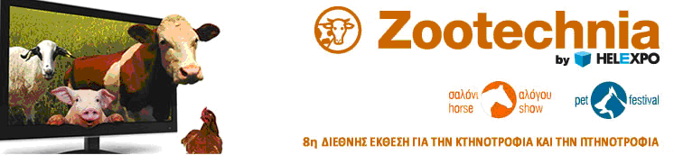
1. Exhibition Title: | Zootechnia  9th International exhibition for livestock and poultry  (Open to professionals and the public)
2. Exhibition Date: | 29/01-01/02/2015
3. Exhibition Place: | International Exhibition & Congress Center of HELEXPO, Thessaloniki
4. Exhibition Total Space 2013 (in square meters): | 10.127 sq.m.
5. Exhibit products: | Machinery and equipment for Animal Husbandry - Aviculture, Processing- Maintenance-Manufacturing-Packaging Machinery, Animal Husbandry & Aviculture Products, Pharmaceuticals, Animal feed - Raw Materials, Animals (beef cattle, swine, goats/sheep, poultry, etc), Accessories and supplies, Agencies and Services, PC-Software, Trade Publications, Financial Press
6. Frequency that the Exhibition is held: | Biennially
7. Date of the First Exhibition that was held: | 1999
8. Exhibition Space Rent (in EURO): | Covered area non equipped (type 1): € 80 /sq.m.  Covered area shell-scheme stand (type 2): €80 + €19 / sq.m .  Open-air space: € 45 / sq.m.  Registration fee for each exhibitor 115 €
9. Opening Hours: | Thursday, Friday, Sunday: 10.00 - 19.00 pm  Saturday: 10.00 am - 20.00 pm
10. Full Exhibition Organizer’s Details: | TIF-Helexpo S.A., Egnatia 154,  Tel.:0030 2310291101, 0030 2310291545 Fax: 0030 2310291551, URL: www.helexpo.gr  e-mail: zootechnia@helexpo.gr  Project Manager: Mr Vasilis Spyrou
11. Number of Exhibitors 2013 | a) Greek (direct): 215 (indirect: 12)  b) Foreign (direct): 10 (indirect: 344)
12. Number of Visitors 2013 | a) Greek: 41.552, b) Foreign: 612  Total: 42.164
13. Countries that participated in the Last Exhibition: | Directly participating:  Austria, Bulgaria, Italy, Germany, Spain, Turkey  Participating through representatives:  Austria, Australia, Belarus, Belgium, Bulgaria, Brazil, Canada, China, Cyprus, Czech Republic, Denmark, Finland, France, Germany, Great Britain, India, Ireland, Israel, Italy, Japan, Korea, Norway, Poland, Portugal, Romania, Russia, Scotland, Slovenia, Spain, Sweden, Switzerland, The Netherlands, Turkey, U.S.A.

