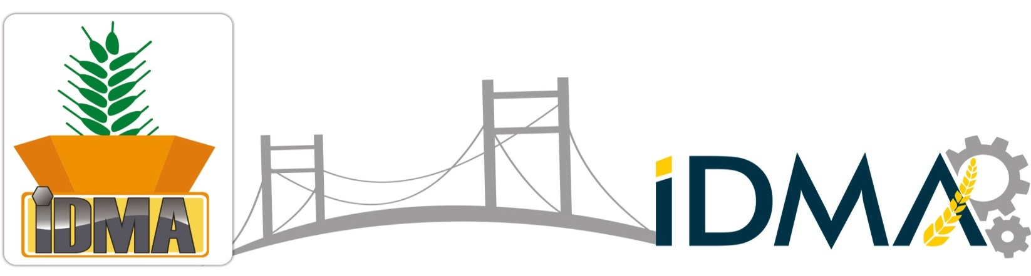
6. International Flour, Semolina, Rice, Corn, Bulghur,
Feed Milling Machinery & Pulse, Pasta, Biscuit Technologies Exhibition
23 - 26 April 2015
Istanbul Expo Center (CNR) / ISTANBUL
Hall 1-2-3
WHY SHOULD BE VISITED?
Being the sole broad participation technology fair in the world in terms of its own expertise area, IDMA presents following opportunities;
- Wide range of machinery, products and services sought for any company are available at same place,
- The latest technologies improved regarding relevant expertise area can be seen and analyzed closely,
- The opportunity to interview with the biggest technology companies participating to the fair, to receive respond to relevant questions and to make cooperation with them,
- The possibility to compare companies developing similar technologies and accordingly, the technologies improved by such companies,
- The possibility to have knowledge about many issues, such as latest technological improvements, developing markets, production-consumption data in the world, new trends, etc. by means of the activities arranged within the scope of the fair.
Exhibited Product Groups:
- Flour Mill Machinery and Equipment  - Semolina Mill Machinery and Equipment  - Corn Mill Machinery and Equipment  - Rice Mill Machinery and Equipment  - Feed Mill Machinery and Equipment  - Pulse Cleaning and Packing Machinery and Equipment  - Pasta Production Machinery and Equipment  - Biscuit Production Machinery and Equipment |  | - Grain Storage Silos  - Filling, Conveying and Evacuation Systems  - Laboratory Equipment  - Additives  - Packaging Machinery and Equipment  - Spare Parts and Supplier Industry  - International Grain and Pulse Dealers
FOR MORE INFORMATION AND INVITATION please fill out the form below and send us to project1@idma.com.tr or fax: +90 212 212 02 04
Company Name: |  |  | Note:
Name & Surname:
Phone:
Fax:
GSM:
E-Mail & Web:
Address:
PARANTEZ INTERNATIONAL FAIR

Phone: +90 212 347 31 64 Fax: +90 212 212 02 04 E-Mail: info@idma.com.tr Web: www.idma.com.tr

