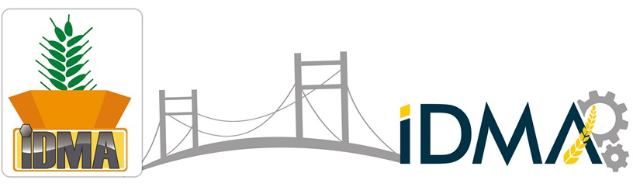

6th International Flour, Semolina, Rice, Corn, Bulghur, Feed Milling Machinery & Pulse, Pasta, Biscuit Technologies Exhibition
23 – 26 April 2015
Istanbul Expo Center – İstanbul Fuar Merkezi (CNR), Hall: 1-2-3
Visiting Hours: 23-25 April 2015 / 10:00 – 19:00 26 April 2015 / 10:00 – 17:00
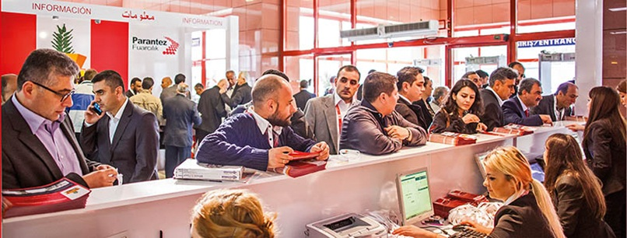

BEING THE SOLE BROAD PARTICIPATION TECHNOLOGY FAIR IN THE WORLD IN TERMS OF ITS OWN EXPERTISE AREA,
IDMA PRESENTS FOLLOWING OPPORTUNITIES
Wide range of machinery, products and services sought for any company are available at same place,
The latest technologies improved regarding relevant expertise area can be seen and analyzed closely,
The opportunity to interview with the biggest technology companies participating to the fair, to receive respond to relevant questions and to make cooperation with them,
The possibility to compare companies developing similar technologies and accordingly, the technologies improved by such companies,
The possibility to have knowledge about many issues, such as latest technological improvements, developing markets, production-consumption data in the world, new trends, etc. by means of the activities arranged within the scope of the fair.

“If you have any investment plan related with flour, semolina, rice, corn, bulghur, feed milling machineries and pulse, pasta, biscuit technologies, you should visit IDMA Fair, as you will have the opportunity to analyze and compare many technological alternatives in this fair.”

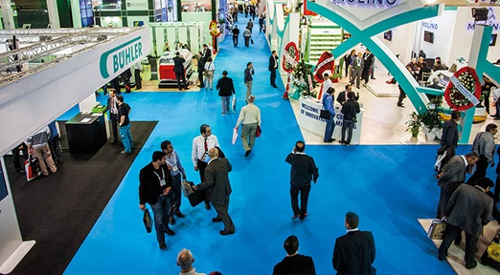 |  | Product Groups  - Turnkey Flour Mill  - Turnkey Semolina Mill  - Turnkey Corn Mill  - Turnkey Rice Mill  - Turnkey Feed Mill  - Pulse Cleaning and Packing Plant  - Turnkey Pasta Plant  - Turnkey Biscuit Mill  - Grain Storage Silos  - Filling, Conveying and Unloading Systems  - Laboratory Equipment  - Additives  - Packaging Machinery and Equipment  - Spare Parts and Supplier Industry  - International Grain and Pulse Dealers
www.idma.com.tr | 

Parantez International Fair Construction Trade Gmbh.
Hadımköy Kavşağı, Atatürk Mahallesi 531. Sok. Ginza Corner Plaza, No:16/37 Kıraç - Esenyurt - İstanbul – TURKEY
Tel: +90 (212) 347 31 64 Fax: +90 (212) 212 02 04 info@idma.com.tr

